REFERRAL TO PRIVATE FACIAL PAIN CLINIC

Please post or email this completed referral pro forma using the contact details above

Please note that this document has been created using Windows 10 – therefore the checkbox system may not function with older versions of Word

Date

Name and Contact Details of Referring Clinician

Referring Clinician’s Name

Position
Address
Post Code
Telephone Number
Fax Number
Email address

Patient Details

Patient’s Name
Title e.g. Mr, Mrs, Miss etc.
Date of Birth

Gender
Address
 | Post Code
Telephone Number
Email address (mandatory)
Is English the patient’s 1st language? | Yes ☐ | No ☐ |  | If no, then please note that if an interpreter is required the patient is responsible for arranging this
Please note that Dr. McMillan is unable to accept telephone communications from patients or referring clinicians. All contact must be made via email - roddymcmillan@nhs.net

General Medical Practitioner’s Name
Address
Post Code
Telephone Number

Has a dental cause for the pain been excluded?  (Please note that the facial pain clinic only reviews patients who have had a dental cause for their symptoms formally excluded by a dentist) | Yes ☐ | No ☐
Has an ear nose and throat cause for the pain been excluded?  (Facial pain associated with cardinal nasal (blockage, discharge) and /or ear (blockage, discharge, deafness, tinnitus, vertigo) symptoms should be referred for an ENT opinion and have any such causes excluded prior to coming to the facial pain service) | Yes ☐ | No ☐

What is the provisional diagnosis?

CHARACTER OF PAIN

When did the pain first start?

Timing of pain | ☐ | Continuous
 | ☐ | Episodic / paroxysmal (episodes of pain with pain free periods in between)
What does the pain feel like to the patient? E.g. dull, aching, sharp, stabbing, burning

LOCATION OF PAIN

Please check the boxes that best correspond to the location of the pain

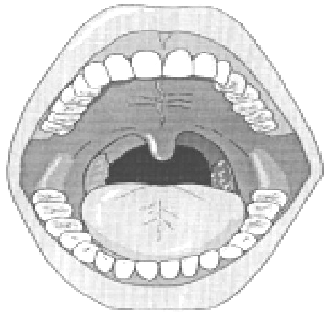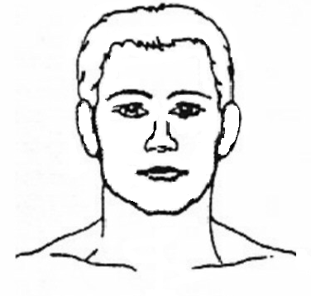
☐
☐
☐
☐
☐
☐
☐
☐
☐
☐
☐
☐
☐
☐
☐
☐
☐
☐
☐
☐
☐
☐
☐
☐
☐
☐
☐
☐
☐
☐
☐
☐
☐
☐
☐
☐
☐
☐
Right
Left

Other details relevant to the location of the facial pain

Please specify:

Any other chronic pains affecting other parts of the body?

If yes, please provide details:

CURRENT / PAST MEDICATIONS AND TREATMENTS FOR PAIN

Medication name | Current  (yes/no) | Dose | Duration of use | Effective  (yes/no) | Adverse effects

OTHER TREATMENTS FOR PAIN (e.g. occlusal splints, dental restorations, endodontics, extraction, physiotherapy, osteopathy, alternative medicine, acupuncture, low intensity laser, TENS, homeopathy, chiropractor, hypnosis)

Please specify:

PREVIOUS CONSULTATIONS FOR PAIN (e.g. GP, oral surgeon, neurologist, physician, psychiatrist, ENT surgeon, neurosurgeon, psychologist, pain specialist, counsellor, rheumatologist)

Please specify:

MEDICAL AND PSYCHOLOGICAL HISTORY

MEDICAL ISSUE | YES | NO | DETAILS
Previous operations / hospital admissions | ☐ | ☐
Cardiac / hypertension | ☐ | ☐
Respiratory | ☐ | ☐
Dermatological | ☐ | ☐
Diabetes / other endocrine | ☐ | ☐
Gastrointestinal | ☐ | ☐
Liver / Hepatitis | ☐ | ☐
Renal | ☐ | ☐
Musculoskeletal / other pains | ☐ | ☐
Neurological / migraines | ☐ | ☐
Mental health | ☐ | ☐
Other medical issues (please give details) | ☐ | ☐
Allergy | ☐ | ☐

CURRENT MEDICATIONS

Please list:

RELEVANT FAMILY / SOCIAL HISTORY THAT COULD INFLUENCE PAIN AND THE PATIENT’S ABILITY TO MANAGE PAIN

Please specify:

ANY OTHER RELEVANT DETAILS?

Please specify:

SIGNATURE OF REFERRING CLINICIAN

Please post or email this completed referral pro forma using the contact details at the head of the pro forma

Please note that Dr. McMillan is unable to accept telephone communications from patients or referring clinicians. All contact must be made via email - roddymcmillan@nhs.net

